FODS ASSIGNMENT 2

Name – Atharva Shivaji Dabkekar
Roll no. – 2090139
PRN - 1251090357
Division – S.Y A
Batch – 2
DATE – 21/07/2026 TIME – 8:00 TO 10:00
QUESTION) Practical 2: Array Operations
Implement one-dimensional array operations including traversal, insertion, deletion, searching, updating, and merging. Compare the execution time of different operations.
ANSWER) We use the clock() function from the <time.h> library to record the CPU time before and after an operation. The execution time is calculated using the formula:
$$\text{Execution Time}=\frac{\text{End Time}-\text{Start Time}}{\text{CLOCKS_PER_SEC}}$$
This gives the time taken by the operation in seconds, which is then displayed on the screen.

ALGORITHM:
Step 1: Start.
Step 2: Read the number of elements (n) of the first array.
Step 3: Read the array elements.
Step 4: Traversal
- Record the start time using clock().
- Display all the array elements.
- Record the end time using clock().
- Calculate the execution time using:
Execution Time = (End Time − Start Time) / CLOCKS_PER_SEC
- Display the execution time.
Step 5: Insertion
- Read the insertion position and value.
- Record the start time.
- Shift all elements one position to the right.
- Insert the new element.
- Increase the array size by 1.
- Record the end time.
- Calculate the execution time.
- Display the updated array and execution time.
Step 6: Deletion
- Read the deletion position.
- Record the start time.
- Shift the remaining elements one position to the left.
- Decrease the array size by 1.
- Record the end time.
- Calculate the execution time.
- Display the updated array and execution time.
Step 7: Searching
- Read the element to be searched.
- Record the start time.
- Compare the element with each array element one by one.
- If found, display its position; otherwise display "Element Not Found".
- Record the end time.
- Calculate the execution time.
- Display the searching time.
Step 8: Updating
- Read the update position and new value.
- Record the start time.
- Replace the existing value with the new value.
- Record the end time.
- Calculate the execution time.
- Display the updated array and execution time.
Step 9: Merging
- Read the size and elements of the second array.
- Record the start time.
- Copy all elements of the first array into the merged array.
- Copy all elements of the second array after the first array.
- Record the end time.
- Calculate the execution time.
- Display the merged array and execution time.
Step 10: Stop.

Pseudo Code:
BEGIN
INPUT n
FOR i ← 0 TO n-1
INPUT A[i]
END FOR
// Traversal
StartTime ← clock()
FOR i ← 0 TO n-1
PRINT A[i]
END FOR
EndTime ← clock()
ExecutionTime ← (EndTime - StartTime) / CLOCKS_PER_SEC
PRINT ExecutionTime
// Insertion
INPUT position
INPUT value
StartTime ← clock()
FOR i ← n DOWNTO position+1
A[i] ← A[i-1]
END FOR
A[position] ← value
n ← n + 1
EndTime ← clock()
ExecutionTime ← (EndTime - StartTime) / CLOCKS_PER_SEC
PRINT A
PRINT ExecutionTime
// Deletion
INPUT position
StartTime ← clock()
FOR i ← position TO n-2
A[i] ← A[i+1]
END FOR
n ← n - 1
EndTime ← clock()
ExecutionTime ← (EndTime - StartTime) / CLOCKS_PER_SEC
PRINT A
PRINT ExecutionTime
// Searching
INPUT key
StartTime ← clock()
found ← -1
FOR i ← 0 TO n-1
IF A[i] = key THEN
found ← i
BREAK
END IF
END FOR
EndTime ← clock()
ExecutionTime ← (EndTime - StartTime) / CLOCKS_PER_SEC
IF found = -1 THEN
PRINT "Element Not Found"
ELSE
PRINT "Element Found at Position", found
END IF
PRINT ExecutionTime
// Updating
INPUT position
INPUT value
StartTime ← clock()
A[position] ← value
EndTime ← clock()
ExecutionTime ← (EndTime - StartTime) / CLOCKS_PER_SEC
PRINT A
PRINT ExecutionTime
// Merging
INPUT n2
FOR i ← 0 TO n2-1
INPUT B[i]
END FOR
StartTime ← clock()
FOR i ← 0 TO n-1
C[i] ← A[i]
END FOR
FOR i ← 0 TO n2-1
C[n+i] ← B[i]
END FOR
EndTime ← clock()
ExecutionTime ← (EndTime - StartTime) / CLOCKS_PER_SEC
PRINT C
PRINT ExecutionTime
END
CODE:
#include <stdio.h>
#include <time.h>

#define MAX 1000

// Function to display array elements
void traverse(int arr[], int n)
{
int i;

printf("\nArray Elements are:\n");

for(i=0;i<n;i++)
{
printf("%d ",arr[i]);
}

printf("\n");
}

// Function to insert an element
void insert(int arr[], int *n, int pos, int value)
{
int i;

for(i=*n;i>pos;i--)
{
arr[i]=arr[i-1];
}

arr[pos]=value;

(*n)++;
}

// Function to delete an element
void deleteElement(int arr[], int *n, int pos)
{
int i;

for(i=pos;i<(*n)-1;i++)
{
arr[i]=arr[i+1];
}

(*n)--;
}

// Function to search an element
int search(int arr[], int n, int key)
{
int i;

for(i=0;i<n;i++)
{
if(arr[i]==key)
return i;
}

return -1;
}

// Function to update an element
void update(int arr[], int pos, int value)
{
arr[pos]=value;
}

// Function to merge two arrays
void merge(int arr1[], int n1, int arr2[], int n2, int arr3[])
{
int i;

for(i=0;i<n1;i++)
arr3[i]=arr1[i];

for(i=0;i<n2;i++)
arr3[n1+i]=arr2[i];
}

int main()
{
int arr[MAX],arr2[MAX],merged[MAX];
int n,n2;
int i;
int pos,value,key;
clock_t start,end;
double cpu_time;

printf("Enter number of elements in first array: ");
scanf("%d",&n);

printf("Enter elements:\n");

for(i=0;i<n;i++)
scanf("%d",&arr[i]);

start=clock();
traverse(arr,n);
end=clock();

cpu_time=((double)(end-start))/CLOCKS_PER_SEC;

printf("Traversal Time = %f seconds\n",cpu_time);

printf("\nEnter position for insertion: ");
scanf("%d",&pos);

printf("Enter value: ");
scanf("%d",&value);
start=clock();
insert(arr,&n,pos,value);
end=clock();
cpu_time=((double)(end-start))/CLOCKS_PER_SEC;
printf("\nAfter Insertion:\n");
traverse(arr,n);
printf("Insertion Time = %f seconds\n",cpu_time);
printf("\nEnter position for deletion: ");
scanf("%d",&pos);
start=clock();
deleteElement(arr,&n,pos);
end=clock();
cpu_time=((double)(end-start))/CLOCKS_PER_SEC;
printf("\nAfter Deletion:\n");
traverse(arr,n);
printf("Deletion Time = %f seconds\n",cpu_time);
printf("\nEnter element to search: ");
scanf("%d",&key);
start=clock();
int index=search(arr,n,key);
end=clock();
cpu_time=((double)(end-start))/CLOCKS_PER_SEC;
if(index==-1)
printf("Element Not Found\n");
else
printf("Element Found at Position %d\n",index);
printf("Searching Time = %f seconds\n",cpu_time);
printf("\nEnter position to update: ");
scanf("%d",&pos);
printf("Enter new value: ");
scanf("%d",&value);
start=clock();
update(arr,pos,value);
end=clock();
cpu_time=((double)(end-start))/CLOCKS_PER_SEC;
printf("\nAfter Updating:\n");
traverse(arr,n);
printf("Updating Time = %f seconds\n",cpu_time);
printf("\nEnter number of elements in second array: ");
scanf("%d",&n2);
printf("Enter second array elements:\n");
for(i=0;i<n2;i++)
scanf("%d",&arr2[i]);
start=clock();
merge(arr,n,arr2,n2,merged);
end=clock();
cpu_time=((double)(end-start))/CLOCKS_PER_SEC;
printf("\nMerged Array:\n");
for(i=0;i<n+n2;i++)
printf("%d ",merged[i]);
printf("\n");
printf("Merging Time = %f seconds\n",cpu_time);
return 0;
}

OUTPUT:
1)INPUT AND TRANSVERSAL )
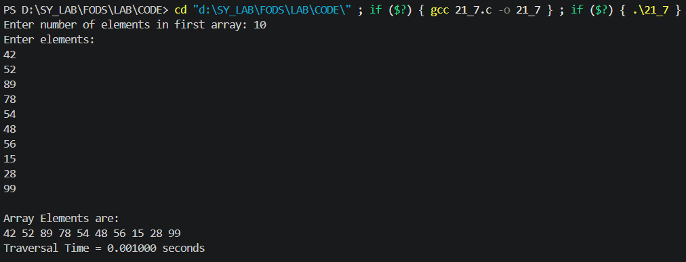

2)INSERTION, DELETION AND SEARCHING)
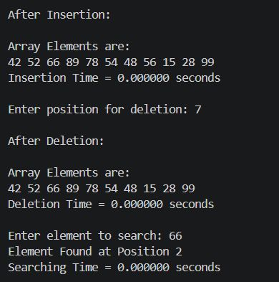

3)UPDATE AND MERGING)
